FACULTY EVALUATION
Programme Name: SBVP ALUMNI MASTERCLASS - SCALE Module I Online Zambia (20th April 2026 - 24th April 2026)
Session: Customers and Markets – what has changed?
Faculty Name: Dr. Nancy Nyambura Njiraini
No. of Respondents: 13
No. of Participants: 13
Evaluation Parameter | (%) Individual Score | (%) Programme Average
Punctuality (Commencement and Completion of Sessions) | 100 | 75
How well do you understand the core concepts presented? | 92 | 72
Rate your confidence in applying the new skills learnt | 93 | 72
Degree of Faculty preparedness for the sessions | 95 | 76
Content and methodology of the program | 97 | 77
Quality of class and group discussions | 88 | 72
The information presented in the course is relevant to my work (ministry) | 97 | 76
Average scores | 95 | 74

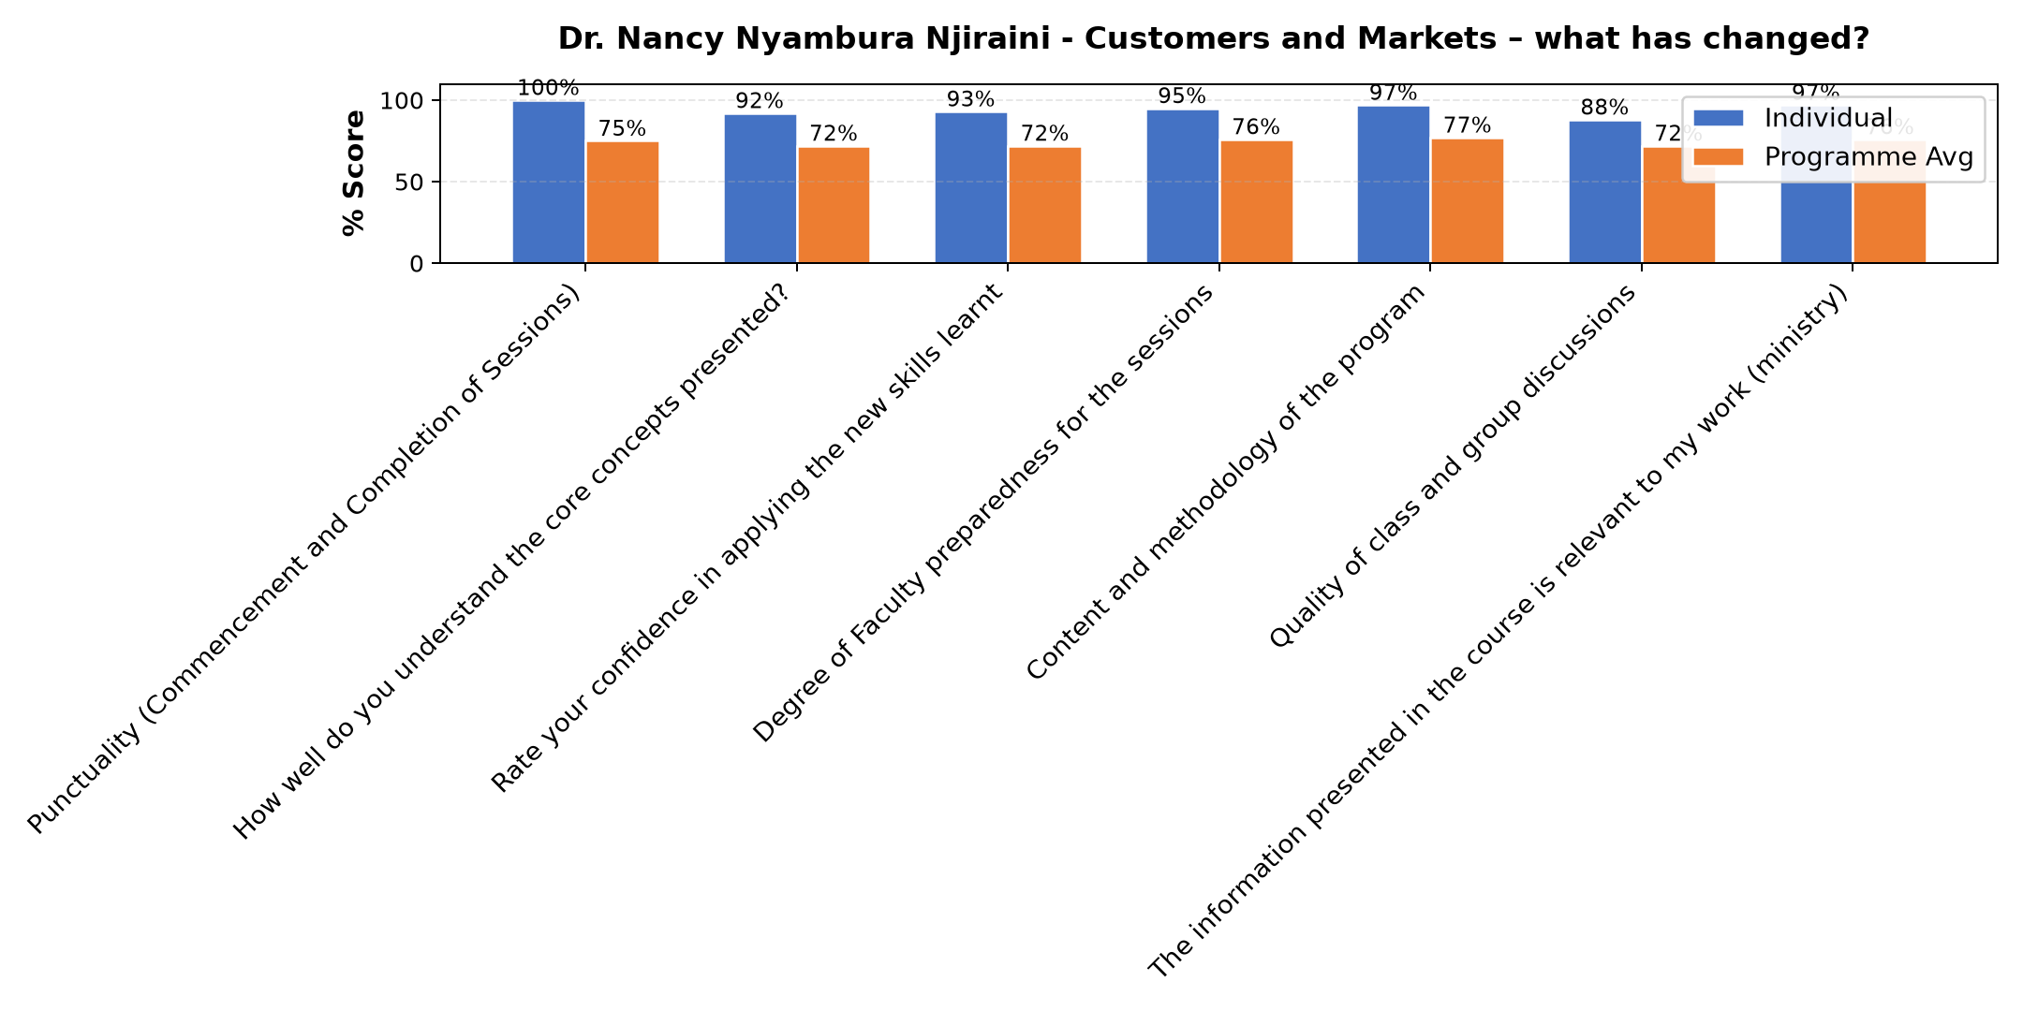

Comments & Feedback
- • Financial resources to help in boosting the project.
- • Inadequate resources.
- • Waiting for everything to be perfect is another barrier,but we can start by picking one small action instead of waiting.
- • Waiting for everything to be perfect is another barrier,but we can start by picking one small action instead of waiting.
- • Nothing, just need proper planning
- • lack of some equipments /Funds
- • Speaker was low , network problems
- • The audio system was straining to hear
- • The audio was straining hearing
- • No barrier will try the best
- • none yet
- • No barriers to prevent me so far
SUBMITTED THROUGH:
SBS Evaluation Automation System

